**DAILY ONLINE ACTIVITIES SUMMARY**

|  |  |  |  |  |  |  |  |  |
| --- | --- | --- | --- | --- | --- | --- | --- | --- |
| **Date:** | **30/05/2020** | | | | | **Name:** | **SPOORTI S DAROJI** | |
| **Sem & Sec** | **4th SEM. & ‘B’ SEC.** | | | | | **USN:** | **4AL18CS088** | |
| **Online Test Summary** | | | | | | | | |
| **Subject** | | **1)DATA COMMUNICATION**  **2)COMPLEX ANALYSIS,PROBABILITY AND STATISTICAL MET** | | | | | | |
| **Max. Marks** | | **1)30**  **2)30** | | **Score** | | | **1)25**  **2)30** | |
| **Certification Course Summary** | | | | | | | | |
| **Course** | **Python for Machine Learning** | | | | | | | |
| **Certificate Provider** | | | **Greatlearning**  **academy** | | **Duration** | | | **5 Hrs.** |
| **Coding Challenges** | | | | | | | | |
| **Problem Statement 1: Write a program to Find size of the largest ‘+’ formed by all ones in a binary matrix.**  **Problem Statement 2: Write a C Program to generate first N Armstrong Numbers** | | | | | | | | |
| **Status: Executed.** | | | | | | | | |
| **Uploaded the report in Github** | | | | | **Yes** | | | |
| **If yes Repository name** | | | | | [alvas-education-foundation](https://github.com/alvas-education-foundation)/[spoorti_daroji](https://github.com/alvas-education-foundation/spoorti_daroji) [spoorti_daroji](https://github.com/alvas-education-foundation/spoorti_daroji)/coding_solutions/ | | | |
| **Uploaded the report in slack** | | | | | **Yes** | | | |

**Online Test Summary:**

* **The 18CS46 test was scheduled from 9:15AM to 10:00AM.The Portion for the IA was the 3rd and 4th module there were 30 questions of one mark & the time assigned was 45 minutes. The questions were mcq type.**
* **The 18MAT41 test was scheduled from 2:55PM to 3:00PM.The Portion for the IA was the 3rd module there were 10 questions of one mark & 10 questions of 2 marks the time assigned was 40 minutes. The questions were mcq type.**

**Online Certification course Summary:**

**In today’s session I have learnt about the Classes and Objects**

* **Class is definition,a blueprint to create an object**
* **Object is encapsulated code consisting of functions,variable and data**
* **Objects are oriented programming is style where self contained logical units of work are**
* **Represented as objects. This makes programming more modular and easy to maintain.**

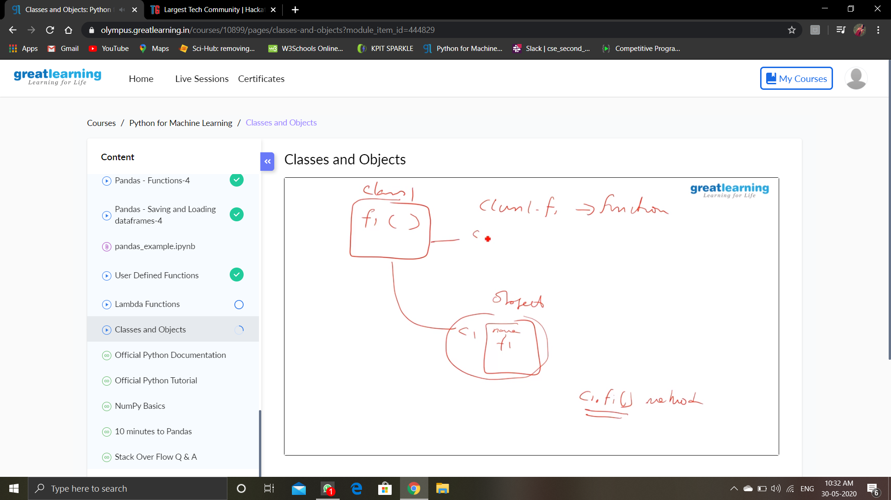

**And I completed my certification course in Python for Machine Learning Successfully.**

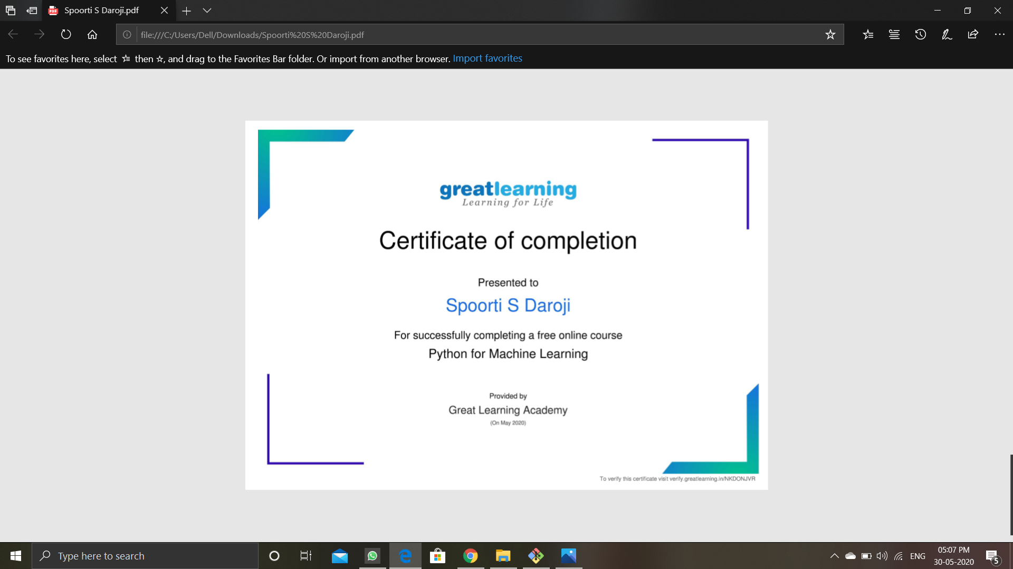

**Online Coding Summary: Today I received the program from prof.Shilpa Hassan CSE Dept and from prof.Venkatesh CSE Dept.**

**The program is mentioned above in the coding challenges.I have written a program and uploaded it to my Github repository, as shown in the below.**

